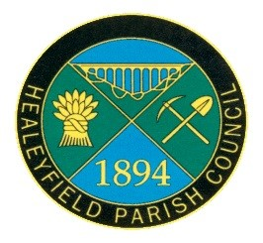
THE MINUTES OF THE ANNUAL MEETING OF ELECTORS OF
THE HEALEYFIELD PARISH COUNCIL
HELD ON THURSDAY 26 MAY 2022

Present:
Councillor A. Pearson (Chair)
Councillors J. Robson, A. Wallace, A. Hird, K. Spencer
Councillor D Oliver
L. Standish (Clerk and Responsible Financial Officer)

1. Apologies for Absence
Councillor Dixon and Councillor McGaun forwarded apologies for absence, both due to ill health.

2. Minutes
It was RESOLVED that the minutes of the Parish Meeting held on Thursday 20 May 2021 be confirmed and signed as a true record.

3. Matters arising
There were no matters requiring update.

4. The Chairman’s Annual Report
The Chair read out his annual report on activities of the Parish Council for the financial year ended 31 March 2022. A copy will be posted on the website and on the notice boards and included in next year's newsletter.

5. Resolutions
No written or verbal resolutions have been received prior to the meeting.

6. Consideration of any other urgent business
No other urgent business was received.

The meeting closed at 7.14pm

Signed ………………………….
Cllr A Pearson
Chair of the Parish Meeting

