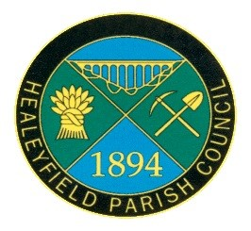
THE MINUTES OF THE ANNUAL MEETING OF ELECTORS OF
THE HEALEYFIELD PARISH COUNCIL
HELD ON THURSDAY 25 MAY 2023

Present: Cllr. A Pearson (Chair)
Cllr. J Robson (Vice-Chair)
Cllr. A Wallace, Cllr. W Todd, Cllr. A Hird, Cllr. K Spencer
DCC Cllr M. McGaun
Mr. I Robson (Parish Clerk)

1 Member of the Public

- Welcome by Chairman of Healeyfield Parish Council
The Chairman of the Parish Council, Cllr. Adam Pearson, welcomed everyone to the Annual Meeting of Electors of Healeyfield Parish Council.
- Apologies
County Cllr D. Oliver
- Agree minutes of the previous Annual Electors Meeting
It was Resolved that minutes of the Annual Electors Meeting held on 26th May 2022 be accepted as a true and correct record.
- Matters arising
There were no matters requiring update.
- Chairman’s Annual Report
The annual report was presented and will be made available on the website.
- Resolutions of which written notice has been given to the Chairman or Clerk
No written or verbal resolutions have been received prior to the meeting.
- Consideration of any other urgent business or matters raised by electors
No other urgent business or matters were received.

The meeting closed at 7.14 pm

Signed ………………………….
Cllr A Pearson
Chair of the Parish Meeting

