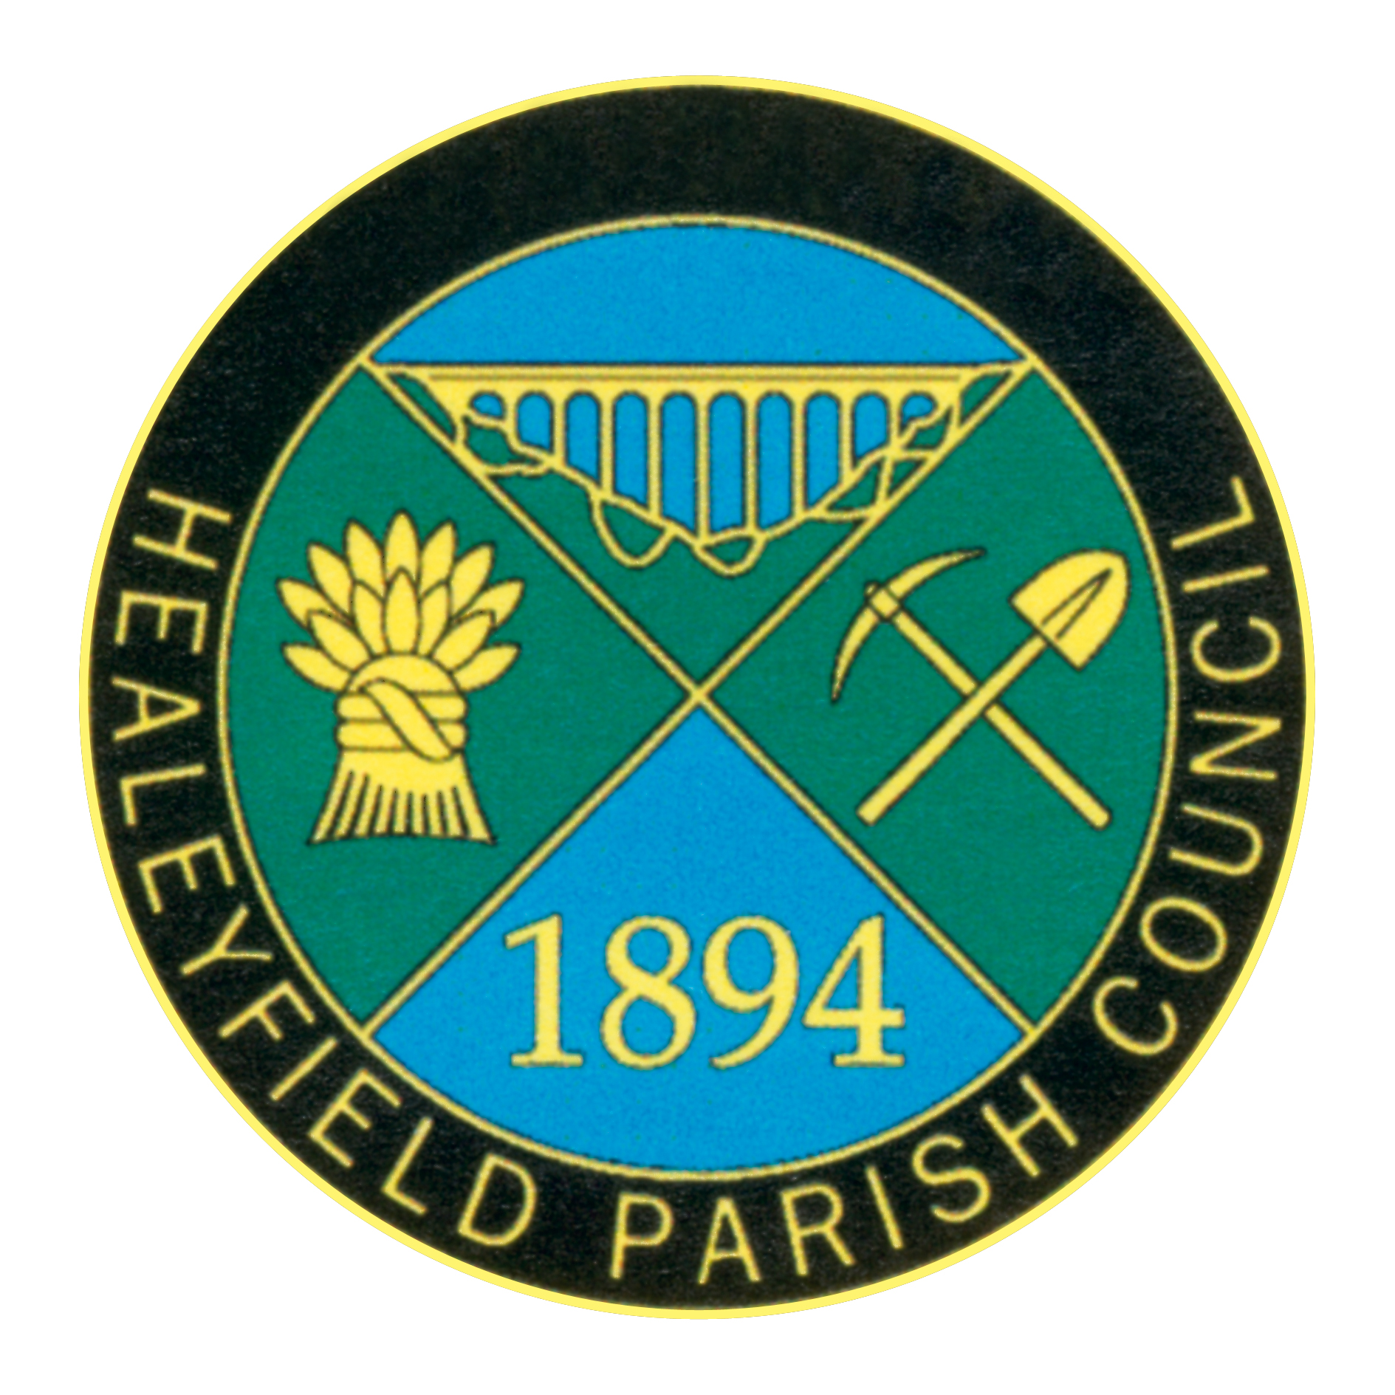
VACANCY FOR PARISH COUNCILLOR

Notice is hereby given that by reason of the recent resignation of a Parish Councillor a vacancy has occurred on the Parish Council. As there have been no requests for an election to be held, the vacancy will be filled by co-option by the Parish Council.

Do you wish to represent the community as a whole?

Do you care about local democracy and want to make a difference in your local area?

Have you got time and commitment to work to improve quality of life around the village you live in?

Any person wishing to fill this position please send your expressions of interest with a brief background profile and why you wish to be a Councillor to contact@healeyfieldparishcouncil.co.uk or in writing to Mr, I, Robson, 39 Castle Hills, Castleside, Consett, County Durham, DH8 9RL.

Closing date: Friday 1st September 2023.
Interviews to be held mid-September.

To qualify, a person must be a British Commonwealth Citizen or EU Citizen (who is a registered elector), over 18 years old, must reside within Healeyfield Parish, or within 3 miles of the boundary, or occupy as owner or tenant any land or premises therein, or have their principal or only place of work there, and must not be disqualified from holding office as a Councillor (details from the Clerk or see the website).

