THE MINUTES OF THE ORDINARY MEETING OF
THE HEALEYFIELD PARISH COUNCIL
HELD THURSDAY 25th APRIL 2024

Present: Cllr. A Pearson (Chair)
Cllr. J Robson, Cllr. K Spencer and Cllr. A Hird
Mr. I Robson (Clerk)

The Chairman opened the meeting at 7.02 p.m.

- Apologies for Absence
Apologies were received from Cllrs. W Todd & A. Wallace
It was Resolved to approve the absences as notified.

- Declarations of Interest
None received.
- Agree minutes of the previous meeting
It was Resolved that the minutes of the Ordinary Meeting held on 27th March 2024 be accepted as true and correct records.
- Public Participation
No members of the public were in attendance.
- Chair’s Report
The Chair reported that the Litter Pick was held on Saturday 13th April, and that the event saw a larger than normal turn out of residents. The Chair thanked everyone for their attendance, and all those who were involved in the organisation of what was a very successful event. The Chair also advised Council that the Clerk’s annual appraisal had been performed during the month and that this will be discussed under agenda item 16.
- County Councillor Report
- The County Councillors were not present.

- Correspondence
  - Northern Powergrid Foundation - Confirmation of receipt of Project Closure Report. ‘Thank you, great read’.
It was Resolved to thank all those involved in the project, which has been successful in it goals, and to receive the correspondence.

  - Cllr. Oliver – Drover Road Sign – added to current work programme. Expected completed within current financial year.
It was Resolved to receive the correspondence.

  - Cllr. Oliver – Road signs at or near to street record road leading to Middle Heads farm, Rowley - added to current work programme. Expected completed within current financial year.
It was Resolved to receive the correspondence.

- Finance
  - Review & Approve End of Year Accounts
Bank Reconciliation
Bank Account balance £ 18,555.85
Less Outstanding Payments £ -
Net Cash Balance £ 18,555.85

Cashbook
Opening Balance 1st April 2023 £ 19,414.40
Receipts £ 16,655.17
Payments £ 17,513.72
Closing Balance 31st March 2024 £ 18,555.85

The 2023/24 budget underspent by £2,444.71 due to delays in delivering planned projects and lower than anticipated General Administration due to the lack of a Parish Newsletter. The End of Year cash balance comprises allocated funds amounting to £12,744.07.
It was Resolved to approve the accounts for 2023/24 as presented.

  - Review 2024 Financial Risk Assessment
It was Resolved to approve the 2024 Financial Risk Assessment

  - Approve AGAR Certificate of Exemption
It was Resolved to certify Healeyfield Parish Council as exempt from a limited assurance review due to neither annual gross income, nor annual gross expenditure exceeding the defined threshold, and to submit AGAR 2023/24 Form 2 to advise the external auditor as such.

  - Review & Approve the Asset Register
It was Resolved to approve the asset register for 2024.
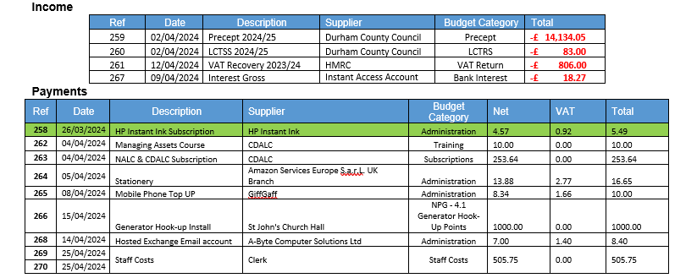
  - Accounts for Payment – April
Note: Item 258 was invoiced and paid by Direct Debit prior to the end of March 2023, and therefore appears in last years accounts, but has been brought to this meeting for retrospective approval
It was Resolved to approve the accounts for payment for April 2024, with a caveat regarding item 263 pending agenda item 12.

  - Responsible Financial Officers Report
- The RFO updated the council on the following items:
  - Precept & LCTSS grant received from Durham County Council
  - VAT reclaim submitted and fund received from HMRC.

Bank Balances:
  - Current £ 4,549.58
  - Savings £ 28,020.94
  - Total £ 32,570.52

  - Less uncleared payments £ 777.79
  - Cash Balance £ 31,792.73
It was Resolved to receive the RFO report.

- Clerk’s Report
  - The clerk reported the following:
- In line with legislation the Period of Electors Rights, which must commence no later than the 1st July and must include the first 10 working days in July, has been set to run from Monday 3rd June to Friday 12th July inclusive.
- The Department of Levelling Up, Housing and Communities (DLUHC) has released details of the appropriate sum for Section 137(4)(a) of the Local Government Act 1972 (the 1972 Act). For parish and town councils in England the 2024-25 Section 137 Limit is £10.81 per elector (£9.93 per elector in 2023-24).
- The Council Insurance will automatically renew on 1st June 2024 – LTA expires 31 May 2025
- Moved Clerk Mobile phone onto PAYG (same provider), so instead of £6 per month for unlimited calls & texts, it will now be:
  - 25p per minute & 10p per text (8p per call for voicemail)

  - Matter for Information
Matters for Information where circulated prior to the meeting and no items were highlighted for discussion.
It was Resolved to receive the Clerk’s report.

- Planning Applications
None received.

- Parish Event Planning
  - Litter Pick
A review of the event was discussed by the Council.
It was Resolved to take the review into account for future litter pick events.

  - D-Day 80th Anniversary
  - Receive updates regarding planning for the event.
  - Scheduling planning meetings
Updates were received from the Clerk and Councillors regarding progress on preparations for this national event, including a quotation received for a fireworks display, and for the purchase of a Gazebo.
It was Resolved to receive the updates on progress.
It was Resolved to approve the quotation for a fireworks display.
It was Resolved to approve the purchase of a Gazebo for use during this event and for future events.
It was Resolved to schedule weekly planning meetings for this event.

- Review CDALC, NALC & SLCC membership.
  - To determine continued membership for the next 12 months.
The Clerk explained the benefits of membership, specifically regarding the support provided to both the Council and the Clerk, and the value of being part of a network of local councils both locally and nationally.
It was Resolved to continue with membership of NALC & CDALC.
It was Resolved to approve payment item 263 within this month’s payment summary.

- Website & Email - Migration to gov.uk domain
  - To receive a report on migrating to a gov.uk domain
It was Resolved for the Clerk to continue the investigations into this topic and to bring this back to the council at a future meeting.

- Castleside Show
  - To determine key milestones in the planning process
It was Resolved to continue the planning activities and keep this under regular review.

- Date of the next Ordinary Meeting
  - It was Resolved that the date and time of the next meeting is Thursday 30th May 2024.

Public Bodies (Admission to Meetings) Act 1960, s.1(2). A body may, by resolution, exclude the public from a meeting (whether during the whole or part of the proceedings) whenever publicity would be prejudicial to the public interest by reason of the confidential nature of the business to be transacted or for other special reasons stated in the resolution and arising from the nature of that business or of the proceedings; and where such a resolution is passed, this Act shall not require the meeting to be open to the public during proceedings to which the resolution applies.

- Confidential Items
1 item was discussed.

Meeting ended at 9.02 pm

Chair …………………………………………….. Date ………………………..

