THE MINUTES OF THE ANNUAL MEETING OF
THE HEALEYFIELD PARISH COUNCIL
HELD THURSDAY 30th MAY 2024

Present: Cllr. A Pearson (Chair)
Cllr. J Robson, Cllr. K Spencer, Cllr. Wallace and Cllr. A Hird
Mr. I Robson (Clerk)

The Chairman opened the meeting at 7.07 p.m.

- Election of Chairman
It was Resolved to elect Cllr. A. Pearson as the Chairman of the Parish Council.
- Acceptance of Office of Chairman
The Declaration of Acceptance of Office was signed by Cllr. Adam Pearson and witnessed by Mr. Ian Robson (Clerk).
- Apologies for Absence
None received.
- Election of Vice Chairman
It was Resolved to appoint Cllr. J. Robson as vice-chairman of the Parish Council.
- Declarations of Interest
None received.
- Appointment of Internal Auditor
It was Resolved to appoint Gordon Fletcher as the Internal Auditor for 2024/25.
- Agree minutes of the previous meeting
It was Resolved that the minutes of the Ordinary Meeting held on 25th April 2024 be accepted as a true and correct record.
- Public Participation
No members of the public were in attendance.
- Chair’s Report
The chair reported that they received the resignation of Bill Todd during May, and that the principal authority has been informed. The Chair expressed the gratitude of the Council for the time and effort which Mr. Todd had put into the role, and commented that he had been a great asset to the council during his tenure as a Councillor.
- County Councillor Report
- Cllr. M. McGaun updated the council on the following topics:
  - Planning application submitted for Lincoln House change of Use.
  - North-East Combined Authority update – secured £99m for County Durham.
  - Impact on DCC funding of Durham students not paying Council Tax and discussions with DLUHC government department.
  - Adult Health Services and the ongoing Care Quality inspection.
  - Make your Mark awards – Newton Aycliffe Business Park.
  - Beamish Museum Board – setting future strategy for its’ future development.
  - Increase in Dog Centre occupancy – cost pressure to round up stray dogs.
  - Cllr. McGaun has resigned as a conservative councillor and is now independent.

- Cllr. Pearson reminded Cllr. McGaun about the narrowing of Longedge Lane in certain areas.

It was Resolved to receive the County Councillors report.

- Correspondence
  - St John’s Church – Response to Pyramid & Poppy Net Memorandum of Understanding.
It was Resolved to respond to St John’s Church regarding their objection to the pyramid being erected in the church garden, and the display of the poppy net.

- Finance
  - Accounts for Payment – May
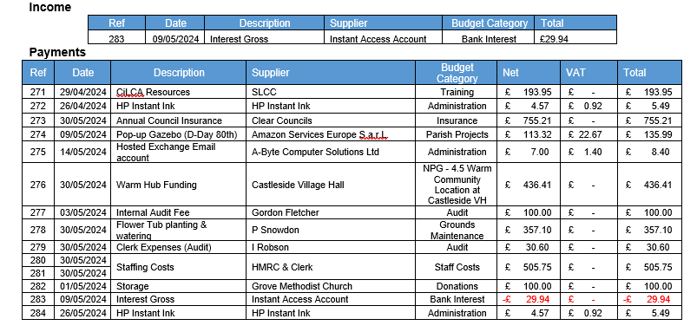
It was Resolved to approve the accounts for payment for May 2024.

  - Responsible Financial Officers Report
- The RFO advised the council of the following budget information:
  - Recommendation to close ‘NPG – 4.1 Generator Hook-up Points’ and move the remaining funds, (£62.00), to ‘NPG 4.2 Reusable Supplies’.
It was Resolved to accept the recommendation.

  - To address the shortfall in D-Day 80th funding, (c.£1,300), it was recommended to reallocate funds from ‘Parish Events’ (£200) & ‘General Reserves’ (£1,100).
It was Resolved to provisionally accept the recommendation but also to pursue grant opportunities to address the shortfall.

  - NPG4.5 Warm Hub Funding - Based upon the 9 sessions claimed for February & March, and with a total reclaim of £436.41, this equates to £48.49 per session. With a current budget category balance of £1,026 that potentially provides enough funding for c. 21 further weeks of Warm Hub sessions.
It was Resolved to receive the information and for the clerk to share with the Chair of the Village Hall committee.

- Bank Balances:
  - Current £ 3,336.36
  - Savings £ 28,050.88
    - Total £ 31,387.24

  - Less uncleared payments £ 2,198.96

  - Cash Balance £ 29,188.28
It was Resolved to receive the RFO report.

- Clerk’s Report
  - 2024 Review of Internal Control
It was Resolved to approve the 2024 Review of Internal Control.
  - Receive Annual Internal Report
It was Resolved to receive and approve the Annual Internal Report.
  - Approve Annual Governance Statement
It was Resolved to approve the Annual Governance Statement.
  - Approve Accounting Statements
It was Resolved to approve the Accounting Statements.
  - Councillor Summons
All Councillors agreed to receive summons and agenda by email for the next 12 months.
  - Matter for Information
Updates were provided regarding matters for information.
  - Full dog bins were reported to DCC and subsequently emptied.
  - Councillor Vacancy Notice posted 17th May and will run until 7th June.
It was Resolved to receive the Clerk’s report.

- Planning Applications
  - DM/24/00983/FPA A Wilderness Way Ltd
Treetops, Rowley Bank, Rowley, Consett, DH8 9AE
Change of use of residential dwelling (Use Class C3) to children’s home (Use Class C2) for one child aged between 8-17.
It was Resolved not to make a comment on this planning information.
- Parish Event Planning
  - D-Day 80th Anniversary
Receive updates regarding planning for the event.
It was Resolved to receive the updates on progress.
- Website, Email & Migration to Gov.uk domain
  - To receive a report from the Clerk regarding the options for obtaining additional email addresses and migrating to a gov.uk domain.
It was Resolved that the Clerk should progress with a bespoke quotation from Activecouncil.co.uk for the provision of emails addresses, website hosting and a gov.uk domain.
- MS Office Licenses
  - To discuss a proposed contract amendment to avoid MS licensing increases.
It was Resolved to remain on a monthly commitment for MS licenses.
- Grass Cutting
  - To determine the contractor and date of cutting
It was Resolved to appoint RB Trees & Landscapes Ltd to perform the grass cutting and strimming for 2024.
- Date of the next Ordinary Meeting
  - It was Resolved that the date and time of the next meeting is Thursday 27th June 2024.

Public Bodies (Admission to Meetings) Act 1960, s.1(2). A body may, by resolution, exclude the public from a meeting (whether during the whole or part of the proceedings) whenever publicity would be prejudicial to the public interest by reason of the confidential nature of the business to be transacted or for other special reasons stated in the resolution and arising from the nature of that business or of the proceedings; and where such a resolution is passed, this Act shall not require the meeting to be open to the public during proceedings to which the resolution applies.

- Confidential Items
Nothing discussed.
Meeting ended at 8.31 pm

Chair …………………………………………….. Date ………………………..

