THE MINUTES OF THE ORDINARY MEETING OF
THE HEALEYFIELD PARISH COUNCIL
HELD THURSDAY 20th JUNE 2024

Present: Cllr. A Pearson (Chair)
Cllr. J Robson, Cllr. K Spencer, Cllr. A Wallace and Cllr. A Hird
Mr. I Robson (Clerk)

The Chairman opened the meeting at 7.07 p.m.

- Apologies for Absence
None received
- Declarations of Interest
None received.
- Agree minutes of the previous meeting
It was Resolved that the minutes of the Annual Meeting held on 30th May 2024 be accepted as true and correct record.
- Public Participation
No members of the public were in attendance.
- Chair’s Report
The Chair reported on the impressive attendance at the D-Day 80th Anniversary event held on Thursday 6th June 2024. It was reported that c.455 people were in attendance, possibly more as the count was taken after several people had already left. The chair wished to thank everyone who was involved in making the event a success, and positive feedback as been received from several attendees.
- County Councillor Report
The County Councillors were not present.

- Correspondence
  - Resident – Condition of Drovers Dell Sandpit
It was Resolved to receive the correspondence and to note that the Clerk had directed the resident to the Village Hall.

  - Cllr. McGaun – Thank you letter regarding the D-Day Event held on 6th June 2024.
It was Resolved to receive the correspondence with thanks.

  - Piggy Blinders (Heather & Paul) – Thank you message regarding the D-Day Event held on 6th June 2024.
It was Resolved to receive the correspondence with thanks.
- Finance
  - Accounts for Payment – June
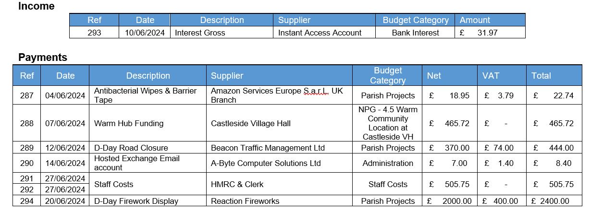
It was Resolved to approve the accounts for payment for June 2024.
  - Responsible Financial Officers Report
- The RFO updated the council on the following items:
Bank Balances:
  - Current £ 1,114.66
  - Savings £ 28,082.85
  - Total £ 29,197.51

  - Less uncleared payments £ 3,823.87
  - Cash Balance £ 25,373.64
It was Resolved to receive the RFO report.

- Clerk’s Report
  - The clerk reported the following:
- Council Insurance renewed for the final year of a 3-year deal.
- Durham County Council Electoral Services have confirmed that no requests for an election were received and therefore the vacancy, created by Mr. W. Todd’s resignation, can be filled by co-option.

  - Matter for Information
The following items were highlighted for information.
- 5.2 Dog Stile & 6 Parish Wood Fences – No response from the contractor.
It was Resolved to award the Dog Stile & Fencing work to another contractor.
It was Resolved to receive the Clerk’s report.
- Planning Applications
None received.
- D-Day 80th Anniversary thanks & donations
It was Resolved to send Thank You cards to those who made the event a success, and to send donations to Consett Brass and Castleside Scouts.
- Revised Financial Regulations
It was Resolved to approve and adopt the revised Financial Regulations.
- Email & Website – gov.uk
It was Resolved to proceed with the quotation from Activecouncils.co.uk and move to a gov.uk domain at the end of the current contract.
- Historical Framed Photographs storage
It was Resolved to catalogue the photographs prior to determining the appropriate storage location.
- 2024 Newsletter
It was Resolved to target delivery of the Newsletter for September this year, and July in following years.
- Date of the next Ordinary Meeting
It was Resolved that the date and time of the next meeting is Thursday 25th July 2024.

Public Bodies (Admission to Meetings) Act 1960, s.1(2). A body may, by resolution, exclude the public from a meeting (whether during the whole or part of the proceedings) whenever publicity would be prejudicial to the public interest by reason of the confidential nature of the business to be transacted or for other special reasons stated in the resolution and arising from the nature of that business or of the proceedings; and where such a resolution is passed, this Act shall not require the meeting to be open to the public during proceedings to which the resolution applies.

- Confidential Items
No items were discussed.
Meeting ended at 8.32 pm

Chair …………………………………………….. Date ………………………..

