THE MINUTES OF THE ORDINARY MEETING OF
THE HEALEYFIELD PARISH COUNCIL
HELD THURSDAY 25th JULY 2024

Present: Cllr. A Pearson (Chair), Cllr. J Robson, Cllr. K Spencer, Cllr. A Wallace
and Cllr. A Hird
County Cllr. M McGaun
Mr. I Robson (Clerk)

The Chairman opened the meeting at 7.02 p.m.

- Apologies for Absence
None received
- Declarations of Interest
None received.
- Agree minutes of the previous meeting
It was Resolved that the minutes of the Ordinary Meeting held on 20th June 2024 be accepted as true and correct record.
- Public Participation
No members of the public were in attendance.
- Chair’s Report
The Chair reported a quiet month with grass cutting, and the plant tubs summer planting, having occurred which has tidied the village and surrounding area.
- County Councillor Report
County Cllr. McGaun provided a report on Durham County Council matters to the Parish Council.
It was also reported that a parish resident has contacted Cllr. McGaun regarding a grass verge and this is being progressed.
It was Resolved to receive the County Councillors report with thanks.
Cllr Wallace raised an issue with pavement cutting during the recent optic cable laying within the village.
Cllr Hird reported recycling and glass being mixed by collection staff.
- Correspondence
  - CDALC – Publication of member addresses in Register of Interests
It was Resolved to receive the correspondence and for the clerk to respond to the consultation on behalf of the Parish Council supporting the removal of member addresses in Register of Interests.

  - Bruno Peek – VE Day 80th Anniversary, 8th May 2025.
It was Resolved to receive the correspondence and to add VE day planning to the agenda of the next meeting.

  - Resident – Wishing to know of any folding tables in the village they could borrow. The clerk provided the resident with the viallge hall email address.
It was Resolved to receive the correspondence.
- Finance
  - Accounts for Payment – July
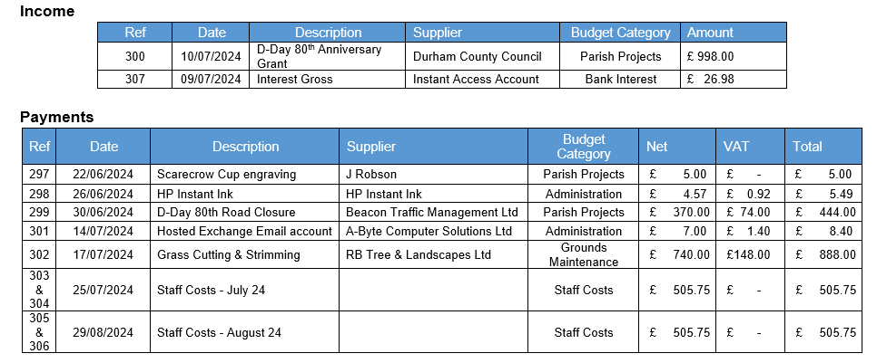
It was Resolved that the clerk should challenge item 299 and payment will be delayed until the challenge is satisfied.
It was Resolved to approve the accounts for payment for July 2024.
  - Responsible Financial Officers Report
The RFO updated the council on the following items:
- Letter from Lloyds Bank regarding FSCS cover.
- August’s Staff payments to be made immediately after July’s, with a delayed payment date, due to council summer recess.
- Bank Balances:
  - Current £ 1,183.30
  - Savings £ 25,109.83
  - Total £ 26,293.13

  - Less uncleared payments £ 2,376.90
  - Cash Balance £ 23,916.23
It was Resolved to receive the RFO report.

- Clerk’s Report
  - The clerk reported the following:
- First grass cutting and strimming occurred Friday 5th July.

  - Matter for Information
- The clerk updated the council of progress updates on Matters for Information items.
It was Resolved to receive the Clerk’s report.

- Planning Applications
DM/24/01557/FPA Mr Daniel Appleby 58 Moorland Crescent, DH8 9RG
Demolition of existing conservatory and construction of single storey rear extension.
It was Resolved to not comment on the application.
- Parish Wood Stile Replacement & Fence Repair
A quotation to replace the existing Parish Wood Stiles was received.

It was Resolved to approve the received quotation and proceed with work as specified.

Acceptable criteria were agreed and delegated to the clerk to minimise delay should a quotation be received for the parish wood fence repair over the recess period.

- Date of the next Ordinary Meeting
It was Resolved that the date and time of the next meeting is Thursday 26th September 2024.

Meeting ended at 7.59 pm

Chair …………………………………………….. Date ………………………..

