THE MINUTES OF THE ORDINARY MEETING OF
THE HEALEYFIELD PARISH COUNCIL
HELD THURSDAY 26th SEPTEMBER 2024

Present: Cllr. A Pearson (Chair), Cllr. J Robson, Cllr. K Spencer, Cllr. A Wallace
and Cllr. A Hird
County Cllr. M McGaun
Mr. I Robson (Clerk)

The Chairman opened the meeting at 7.03 p.m.

- Apologies for Absence
County Cllr. D. Oliver
- Declarations of Interest
None received.
- Agree minutes of the previous meeting
It was Resolved that the minutes of the Ordinary Meeting held on 25th July 2024, and the Extraordinary Meeting held of the 20th August 2024, be accepted as true and correct records.
- Public Participation
1 member of the public was in attendance.
- Chair’s Report
The Chair reported that a discussion had been held with Rev. Martin Jackson regarding the Poppy Net display and Christmas Lights.
- County Councillor Report
County Cllr. McGaun provided a report on Durham County Council matters to the Parish Council.
- Planning application DM/24/02216/OUT (Outline application with access for the erection of up to 13no. dwellings (all other matters reserved) | Land To The North Of Horse And Groom Consett Road Castleside DH8 9QQ) received by County Councillors on 25th September 2024.

It was Resolved that the clerk should contact DCC Planning to investigate why this had not yet been shared directly with the Parish Council as it was received by DCC on the 12th August 2024.
- Stop smoking campaign being ran across the county.
- Motion passed to extend the Council Tax Reduction Scheme for another 12-month period.
- DCC following up on the additional funding due as part of the new combined authority.
- New ASBO controls introduced across County Durham covering, begging in city & town centres, urinating in streets & the use of intoxicating substances.
- Recycling being reviewed. Looking at improvements in recycling across County Durham to support new legislation regarding food waste.
- Staff continue to be moved out of County Hall to other council properties in preparation for the rebuild of County Hall next year.
It was Resolved to receive the County Councillors report with thanks.
Cllr. Pearson asked County Cllr. what impact the proposed DCC budget cuts will have on Healeyfield Parish. County Cllr. McGaun advised that whilst it has not yet been agreed, it is likely that areas such as regular grass cutting of communal areas is an example of what may be impacted.
- Correspondence
  - Derwentside Detached Youth Project – Request for support.
It was Resolved to direct the correspondent to the Parish Council donations policy.

  - CDALC – CDLAC AGM Sat 12th October 2024, invitation for 2 representatives to attend.
It was Resolved for the clerk to respond to CDALC with the council’s attendance plans for the AGM.

- Finance
  - Accounts for Payment
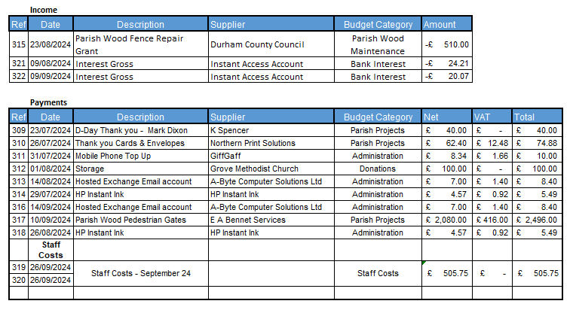
It was Resolved to note the variance between the estimate for item 317 and the actual invoice.
It was Resolved to approve the accounts for payment for September 2024.
  - Responsible Financial Officers Report
The RFO updated the council on the following items:
- Grant of £510 received from County Councillors for the Parish Wood Stiles & Fence repair.
- Bank Balances:
Current £ 1,076.14
Instant Access Account £ 23,654.11
Total £ 24,730.25

Less uncleared payments £ 3,070.15
Cash Balance £ 21,660.10

It was Resolved to receive the RFO report.

- Clerk’s Report
  - The clerk reported the following:
- 2024 Newsletter – Initial Draft received. Comments sent to printer. Second draft to be shared with PC.
- Full Dog Waste Bin reported to DCC late August.

  - Matter for Information
- The clerk updated the council of progress updates on Matters for Information items.
It was Resolved to receive the Clerk’s report.

- Planning Applications
DM/24/02358/RM Wannop Developments Ltd
Land To the Rear Of 1 To 8 Wesley Terrace, Castleside Industrial Estate
Reserved matters application (appearance, landscaping, layout and scale) pursuant to DM/22/01929/OUT
It was Resolved to resubmit the comments which were previously submitted on earlier iterations of this planning application.

- Parish Event Planning
  - Remembrance Day Parade & Service – Sunday 10th November 2024
It was Resolved for the clerk to proceed with arranging the road closure for the Remembrance Day Parade.
  - Christmas Lighting Event - Thursday 28th November 2024
It was Resolved to defer planning until the location of the Christmas lights is confirmed.
  - VE Day 80th – Thursday 8th May 2025
It was Resolved to investigate holding an evening event to celebrate this significant national occasion.

- Parking within the village
  - The Lilacs
  - Rowley Bank verge
It was Resolved to raise the parking issues with Durham County Council.

- Pyramid – Poppy Net & Christmas Lights
Cllr. Pearson provided the council with an overview of a conversation held with Rev. Jackson on this subject.

It was Resolved to continue the discussion with Rev. Jackson and St John’s Parochial Church Council with a view to achieving a positive outcome for the village.

- Date of the next Ordinary Meeting
It was Resolved that the date and time of the next meeting is Thursday 31st October September 2024.

Meeting ended at 9.03 pm

Chair …………………………………………….. Date ………………………..

