THE MINUTES OF THE ORDINARY MEETING OF HEALEYFIELD PARISH COUNCIL HELD THURSDAY 28th NOVEMBER 2024
Present: Cllr. A Pearson (Chair), Cllr. J Robson, Cllr. K Spencer, Cllr. A Wallace
and Cllr. K Piggott.
County Cllrs. M McGaun & D. Oliver
Mr. I Robson (Clerk)
The Chairman opened the meeting at 7.02 p.m.

- Apologies for Absence
None received
- Declarations of Interest
None received
- Agree minutes of the previous meeting
It was Resolved that the minutes of the Ordinary Meeting held on 7th November 2024 be accepted as a true and correct record.
- Public Participation
1 member of the public was in attendance.
- Chair’s Report
The Chair reported that the Remembrance Day parade and service, held on the Sunday 10th November, was attended by c. 120 people and was well received by all who attended. It is hoped that the piper will be available for next year’s parade.
The Chair thanked all those who helped erect the pyramid, the poppy net display and the Christmas lights for the lighting event, which took place immediately before this meeting.
- County Councillor Report
County Cllr. McGaun provided a report on Durham County Council matters to the Parish Council.
- Thank you for Remembrance Day from the County Councillors. What is done in Healeyfield is special and well thought of.
- £11m funding from NE Authority allocated to Net Park project to encourage new businesses.
- Housing needs to be discussed at cabinet to support central government survey.
- £25m invested in Towns & Villages fund following additional £11.5 m added
- Durham Town Hall closed for next 8 months. Expected to open between Easter and Summer.
- Shop closed in Chester-Le-Street for selling illegal tobacco and vapes – DCC clamp down campaign continues.
- Sniperly Park & Ride reopened fully.
- Carers urged to check benefits they are entitled to.
County Cllr. Oliver advised that budget allocations are being discussed, which is relevant to local projects within the ward.
It was Resolved to receive the County Councillors report with thanks.
- Correspondence
  - CDALC – North East Mayor’s Transport Plan Consultation.
It was Resolved that a response should be sent on behalf of the Council containing the following points:
- Suggestion of a limited stop bus in both directions, between Consett and Gateshead Interchange, at peak times.
- Regular occurrence that the Castleside - Durham bus does not turn up in Castleside. This bus is relied upon for school\college transport for several residents.
It was Resolved to also raise the second item above directly with Go North East.
  - Resident – Flooding on road near Castleside Picnic Site
Further correspondence with the resident to confirm the follwing from DCC, ‘The gullies have been cleansed and jetted and the drainage in this area is now working correctly and no further action is required at this time’. A telephone number has been shared with the resident to advise DCC of any future flooding.
It was Resolved to receive the correspondence.
- Clerk’s Report
  - The clerk reported the following:
- Following the publication of the Notice of Vacancy due to the resignation of Adrian Hird, DCC has confirmed that no requests were received to hold an election so the parish council can proceed with co-option to fill the vacant seat.
- Clerk has taken over the fortnightly Defibrillator checking from Adrian Hird.
- DCC reports it has cleansed the layby near Rose Cottage following our report in August 2024.
- Clerks back pay calculated following pay award.
- Lloyds Bank to levy charges on Treasures Account from 14th January 2025.
It was Resolved to maintain the existing account and to monitor the charges going forward.
- Royal Garden Party 2025 nominations are open.
It was Resolved to nominate Cllr. A Pearson for his long service as Chair of the Parish Council.
It was Resolved to receive the Clerk’s report.
  - Matter for Information
It was Resolved to receive the updates provided.

- Finance
  - Accounts for Payment
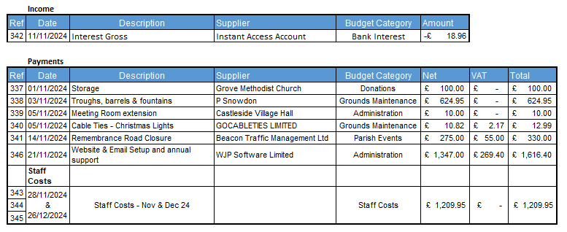
It was Resolved to approve the accounts for payment for November 2024.
It was Resolved to, in the absence of a December meeting, to approve the staff costs for December 2024 with a payment date of 26th December 2024.
It was Resolved to, in the absence of a December meeting, to approve the payment to WJP Software subject to successful delivery of the new website and email addresses.
  - Financial Regulations, para 2.2 report
In accordance with Financial Regulations, para 2.2, after the previous meeting, Cllr. J. Robson verified, and signed, the bank reconciliations with no exceptions noted.
It was Resolved to receive the report.
- Planning Applications
No planning applications received.
- Parish Event Planning
  - VE Day 80th – Thursday 8th May 2025
It was Resolved to submit a grant application to assist with funding this event using quotations received to-date.
  - Determine dates for 2025 events
It was Resolved to set, and advertise, the following dates for 2025 events:
- Litter Pick – Sat 12th April
- VE Day celebration – Saturday 10th May
- Castleside Show - Saturday 16th August
- Remembrance Parade & Service – Sunday 9th November
- Christmas Light Switch-on – Thursday 27th November
- 2024/25 Budget & Precept setting
It was Resolved to approve the budget and set a precept for 2025/26 of £15,476.00. This equates to a Band D charge of £29.88, a 10.00% rise on last year’s precept.

- Parish Council Meeting dates 2025
It was Resolved to set the meeting dates for the last Thursday of each month, with the following exceptions:
- May – Thursday 15th – to comply with election timelines.
- August – No meeting
- December – No meeting
- Community Emergency Plan
Cllr. Wallace updated the Council on the status of the Community Emergency Plan. Cllr. Piggott has agreed to assist with closing out the preparation of this plan.
It was Resolved to receive Cllr. Wallace’s update and to thank Cllr. Piggot for assisting with this plan.
- Date of the next Ordinary Meeting
It was Resolved that the date and time of the next meeting is Thursday 30th January 2025.

Meeting ended at 8.01 pm

Chair …………………………………………….. Date ………………………..

